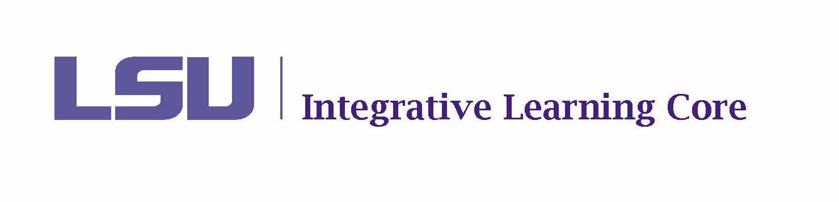

MEETING MINUTES

Faculty Senate Integrative Learning Core Committee

November 4, 2024

2:00-3:00pm

Meeting Location: 129 Himes Hall

Present Members: Aly Aly, Kayanush Aryana, David Chicoine (Chair), Ludovico Geymonat, Kyla Kazuschyk, William Ma, Selena Oswalt (Secretary), Jennifer Qian, Jason Wolfe (Co-Chair).

Not Present: Fanny Ramirez (sabbatical)

Present Ex-Officio: James Murphy, Tachelle White

Agenda
- Call to Order – Quorum met at 2:25.
- Roll Call and Introductions
- Public Comments on Agenda Items - None
- Discussion
- Voting
  - Minutes from September 23, 2024 – Voted and approved
  - Revision to Committee Operating Procedures – Discussed the proposed revisions to the Charges and Operating Procedures document. Tabled until next meeting while revisions regarding assessment are considered.
  - Election of Chair-Elect for 2024-2025 – Tabled until next meeting.
  - New Course Proposals
    - HNRS 2015 – Kai and Kyla approved as is. Voted and approved.
  - ILC Course Deletion
    - Department Drops – Discussed that these courses are being phased out. The department submitted the form to request the drop. No vote needed.
      - HEBR 1001
      - HEBR 1002
      - HEBR 2003
      - HEBR 2004
    - Committee Drops
      - OCS 2100 – Course has not been taught since its ILC approval (Summer 2022). Voted to drop.
      - SOCL 2010 – Course was last taught Spring 2020. Voted to drop.
  - ILC Course Impact Review & Renewal
    - MATH 1021 – David+Ludo approved as is. Voted and approved.
    - MATH 1022 – Kyla+William approved as is. Voted and approved.
    - MUS 1799 – Selena+Jennifer approved as is. Voted and approved.
    - PHIL 1000 – Jennifer+David approved as is. Voted and approved.
    - REL 2027 – Jason+Aly approved as is. Voted and approved.
- New Business
  - Debrief on Elevate Event – Briefly discussed the Elevate event and shared out about sessions attended.

*It is intended that public comments may be made (1) when they relate to a matter on the agenda and (2) when individuals desiring to make public comments have registered at least one hour prior to the meeting by emailing facultysenate@lsu.edu. When registering, individuals should identify themselves; the group they are representing, if appropriate; and the topic on which they would like to comment. To ensure that the meeting is conducted in an efficient manner, each individual will be limited to 3 minutes for their public comments and the President reserves the right to limit the total number of public comments if necessary.
The LSU Faculty Senate or its Committees may meet in executive session as authorized by La. R.S. 42:17.

